GE B6 Digital Multifunctional Balance Charger
[GE B6] USD $67.90 USD $54.90

A good charger is a good investment for your hobby
The GE B6 Charger is a digital controled, multifunctional charger for NiCd/NiMH/Li-polymer/Li-ion/Pb batteries, it can charge up to 15 cells of Nicd/NiMH battery cell and Li-poly battery up to 6 Cells.
By using the Li-Po Balance Charge function, each single cell will be monitored separately, keeping the Li-Po Battery Pack in top performance. You don't need to worry about overcharging, it got Automatic Charge Termination program works on the principle of the Delta-peak voltage detection. You can also Store or Load the data so you don't have to enter for each battery pack.
Specification : - Operating voltage range: 10.0-18.0 Volt
- Circuit Power: MAX charge power 50W, MAX discharge power 5W
- Charge current range: 0.1-5.0A
- Discharge current range: 0.1-1.0A
- Current drain for balacing Li-poer: 300mA/cell
- NiCd/NiMh: 1-15 cell
- Li-ion/Polymer: 1-6 series
- Pb battery voltage: 2V to 20V
- Dimension: 135mm x 100mm x 40mm
Include :
- GE B6 charger 1 Unit
- External tempreture sensor 1 Unit
- DC clamp 1 Unit
- Igniter plug 1 Unit
- JST plug 1 Unit
- DuPont plug for receiver 1 Unit
- English manual 1 Unit

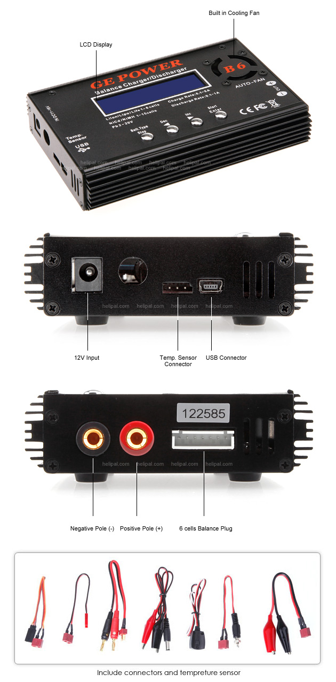

Multi Charging Cable for Li-Po Charger
[LE-0022] USD $8.90

Charge 2 to 3 Li-Po batteries at one time
Best used with a 6 Cells Li-Po charger, you can charge up to 3 X 7.4V batteries or 2 X 11.1V batteries at one time, that means... you are two times or three times faster on preparing a flight.

By using a 6 Cells Li-Po charger, you are able to charge :
- 3 X 7.4V batteries (6S to 2*3S)
- 2 X 11.1V batteries (6S to 3*2S)
- 2 X 7.4V batteries (4S to 2*2S)
Designed for :Li-Po Charger with 6 Cells Balance Plug, for eg. : GE B6 Li-Po Charger

