MP86001Adattatore Polyquest per Equalizer7505
MP86002Adattatore Gr/Ro per Equalizer7505

daptor set Graupner/robbe for EQUALIZER 5505 #86002

 | Contents: one adaptor board for 2S, 3S, 4S and 5S, with connecting lead  Adaptor required for connecting the Graupner / robbe balancer connector system to the  EQUALIZER 5505.
  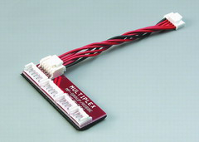
Adaptor set with Polyquest plug for EQUALIZER 5505 #86001

 | Contents: four adaptors for 2S, 3S, 4S and 5S  Adaptor set required for connecting the Polyquest balancer connector system to the  EQUALIZER 5505.
  