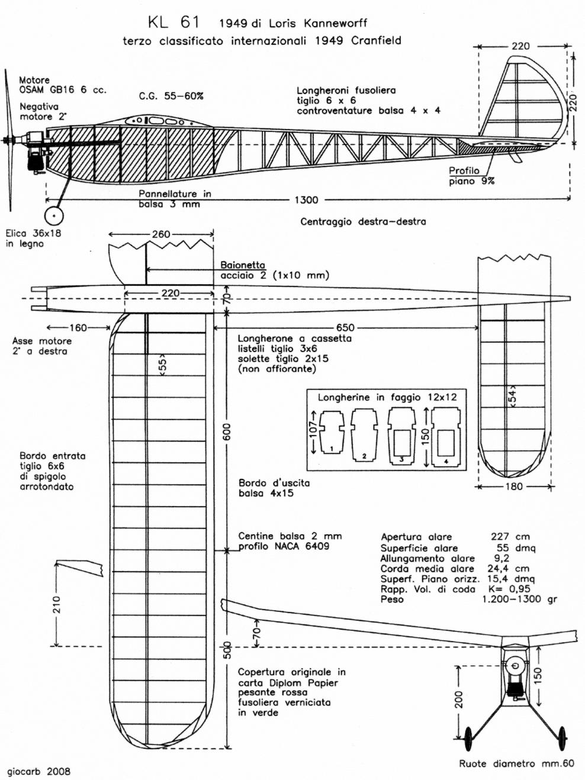

The KL 61
a Loris Kanneworff design
(flown in an International event at Cranfield in 1949)

